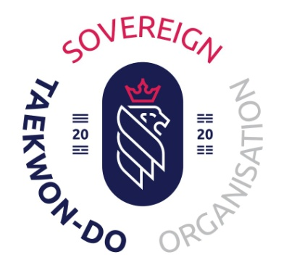
North Wilts Club Committee Meeting Minutes
Meeting date 14th July 2023

Attending: Paul Lolley (PL) Leanne Lolley (LL) James Littleworth (JLIT) Jane Levett (JLEV)
Katie Higgins (KH) Holly Hunt (HH) Peter Davies (PD) Menyee Doyle (MDOY)
Teresa Blackwell (TB)

Apologies: Melissa Dell (MDEL) Robin Doyle (RD)

Minutes taken by TB, please excuse any inaccuracies on TB’s part, this is the first time and some of the information went right over her head, sorry.

This is the first committee meeting with new members. This newly formed committee’s role is to support LL and PL so they can concentrate on other projects.

Roles will be given to members so we all know who the lead and back up is on each role.

- Health and Safety lead will be PL with RD as back up.
- Risk Assessment lead will be RD with KH as back up.
- Data protection lead will be LL with MDOY as back up.
- Safe Guarding lead will be JLEV with MDEL as back up.
- Social Events will be jointly run by KH and TB.

Points 1 through to 4 will need to be reviewed. Point 5 has the BBQ which will need promoting, also need to set a date for the annual awards party. Suggestion was also made that we would like to arrange events, one for the Kicking Bears parents so they have the opportunity to meet and get to know the instructors and other parents, two for the senior grade students to socialize. Also some fund raising activities which will give LL and PL and opportunity to start a sponsored Sovereign Squad.

TCUK Courses /Insurance.

PL was assigned the role of getting more black belts looking to become instructors, to find better courses for instructors and to look into insurance.
? are looking into getting “kite Marks” for the club, this will help get us into the Swindon Sports Forum (SSF)
JLEV will look into the SSF.

Umpire/Referee courses. We need to get some applicants to sign up for this, need to set a date too.

Other business

Leaflet drive for Mr Hewitt based in Parks. We need to get some volunteers when the leaflets are ready to distribute them around the area.

Website maintenance and editing by JLIT and LL.

Pictures need to be taken of instructors and committee members for the website. PD has a photography background we could use, just need to get a decent camera, this is being looked into. PL’s dad to do headshots.

Club Promotion.

Suggestion of a monthly notice board to be set up with Whatsapp so club students can see upcoming events, this will be separate to the other group. This will be trailed to see whether it’s affective.

Social media platforms were discussed to see which one will get more traffic. Facebook and Twitter aren’t as popular so HH will be the lead on Instagram and Tiktok. Side note, check with the ITC lawyer to see whether we need to modify the consent forms as some club members may wish not to be on all social media platforms.

Suggestion was made that the Facebook promotion needs to be more refined, separating International Taekwondo Council from North Wilts and Sovereign.

Feed back for/by instructors. Quarterly reviews will start as soon as possible; PD will create a feedback form to use.

Committee to meet again in 3 months, date to be confirmed.

